Contents

8.Application Load Balancer 1

9.Elastic Load Balancer 7

10. Auto Scaling 7

## 8.Application Load Balancer

Application Load Balancer is an enhanced version of classical ELB, some of the features added are below :

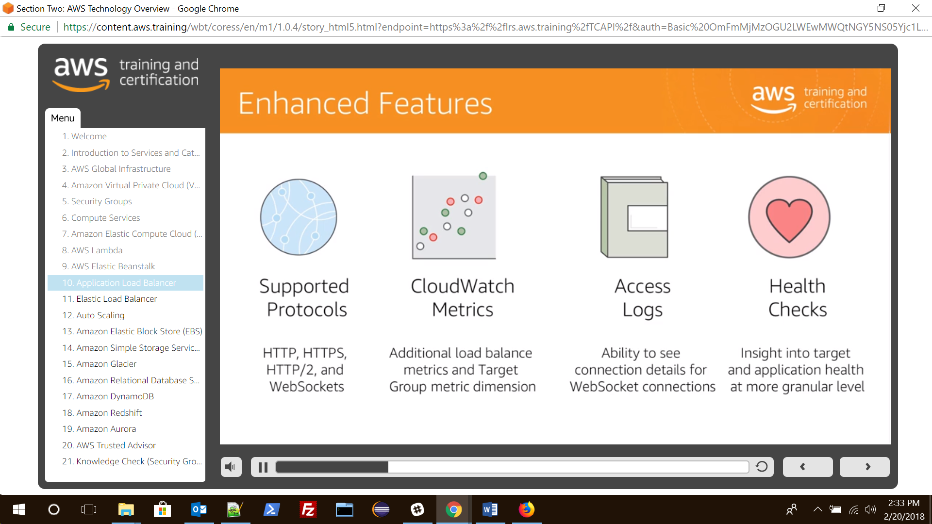

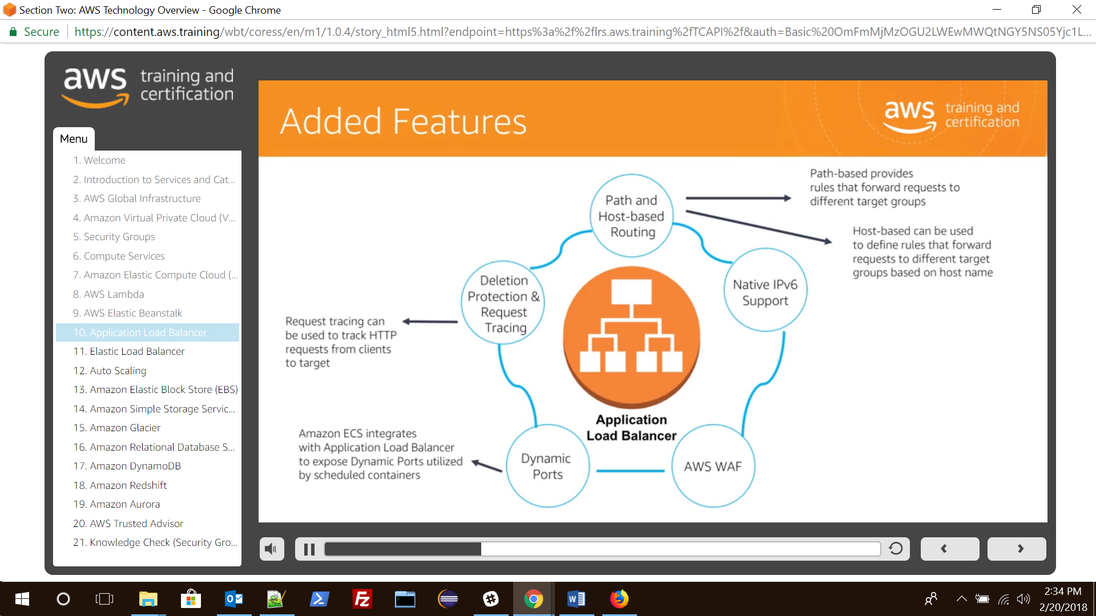

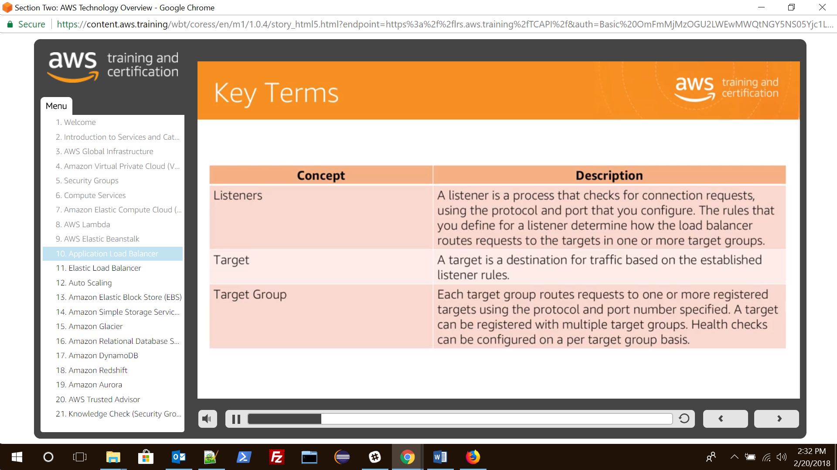

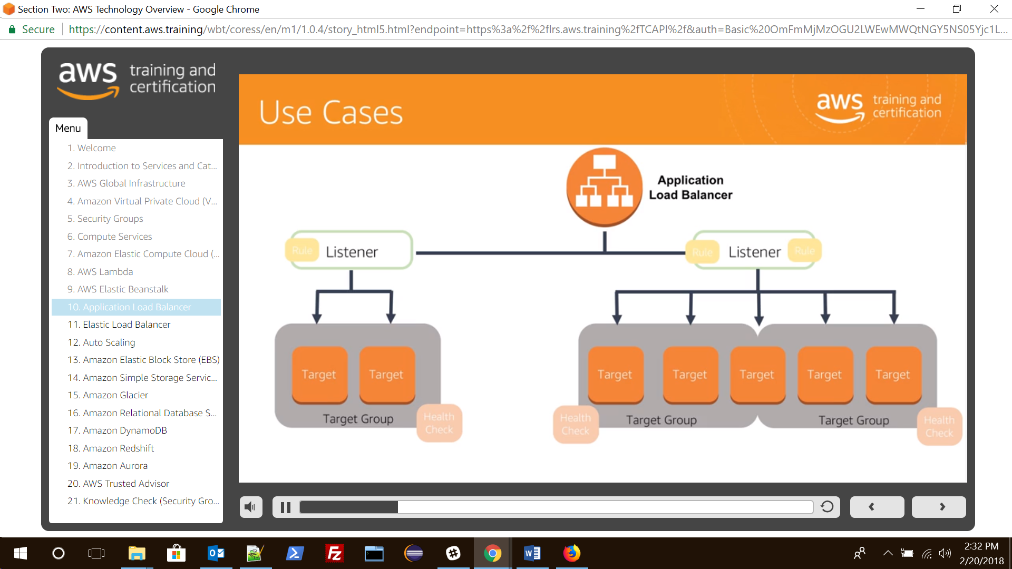

Create an application load balancer

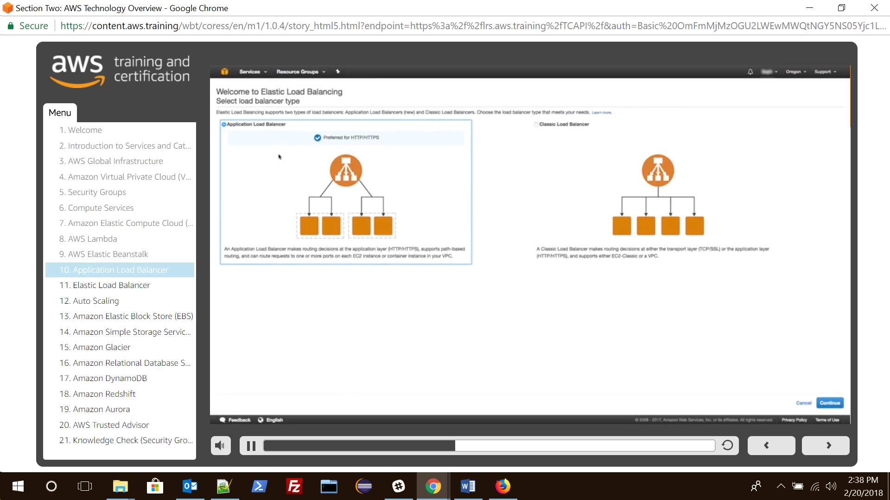

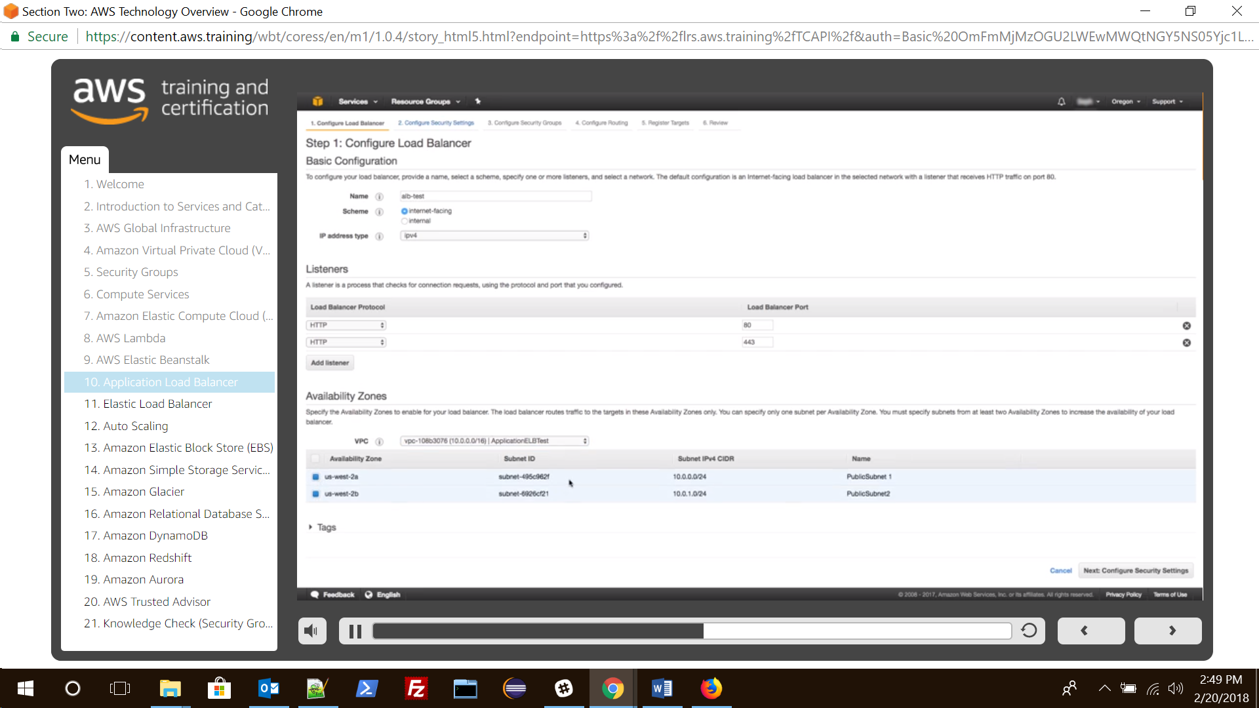

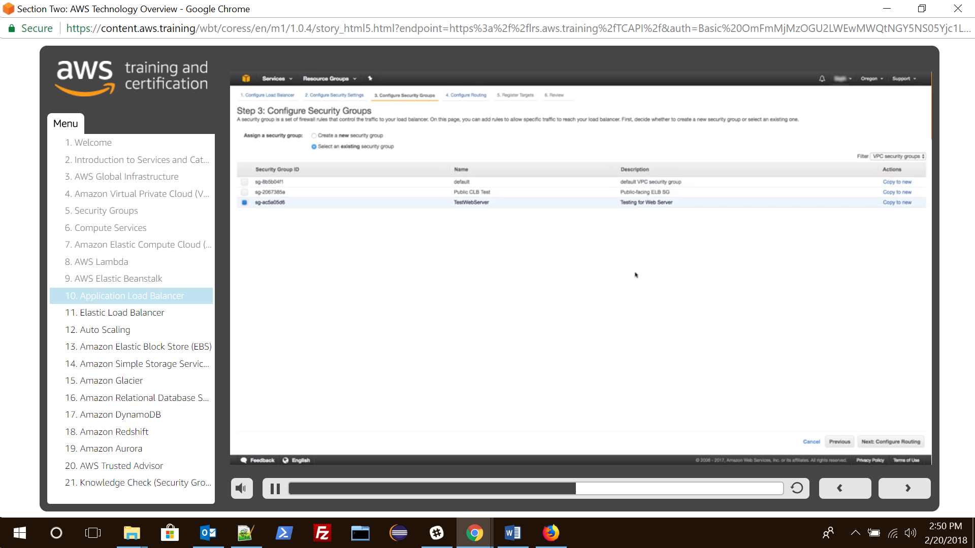

While configuring routing , create or use target group. Which simply means mapping a name to specific port requests and health checks.

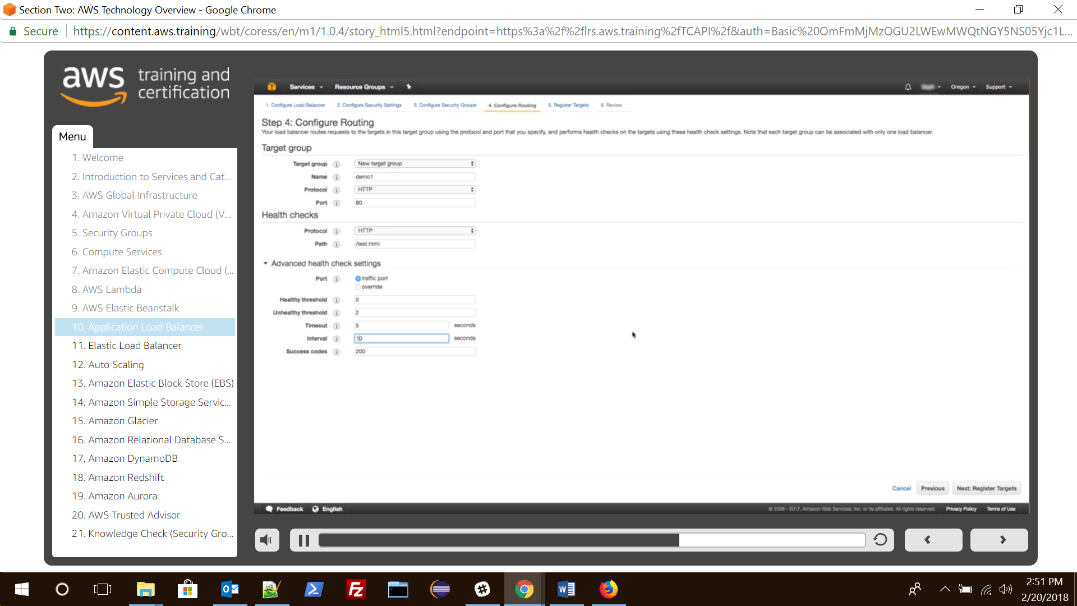

Now register target to the target group

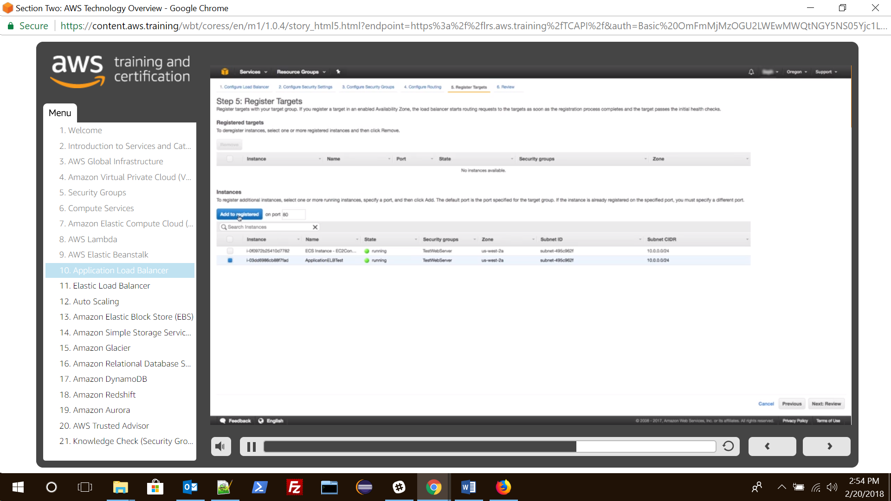

Create another target group for another port

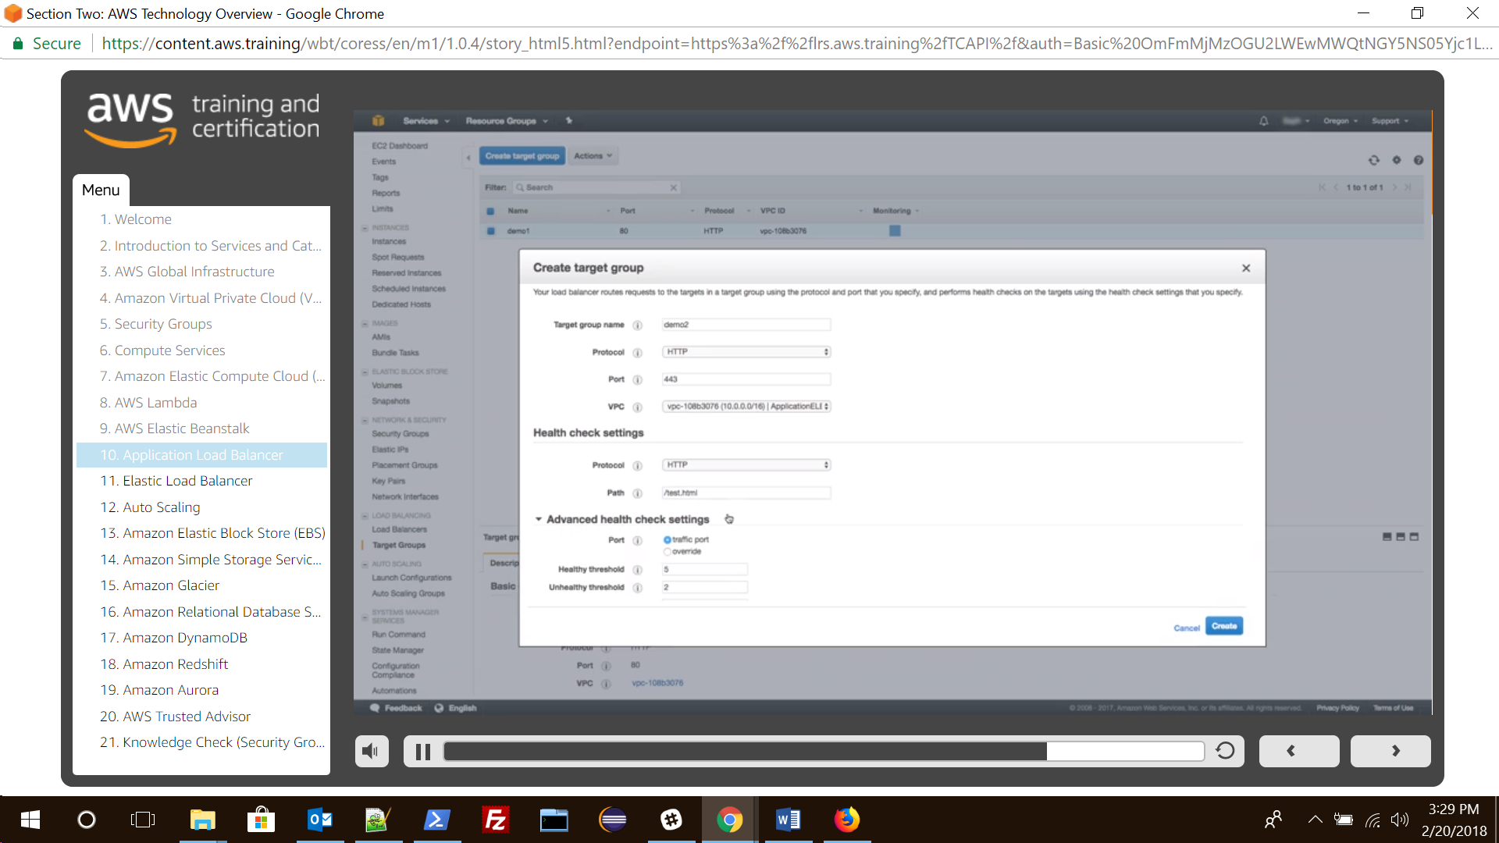

## 9.Elastic Load Balancer

There are two types of load balancer

1. private load balancer
2. internet facing load balancer : it has a public dns associated with it.

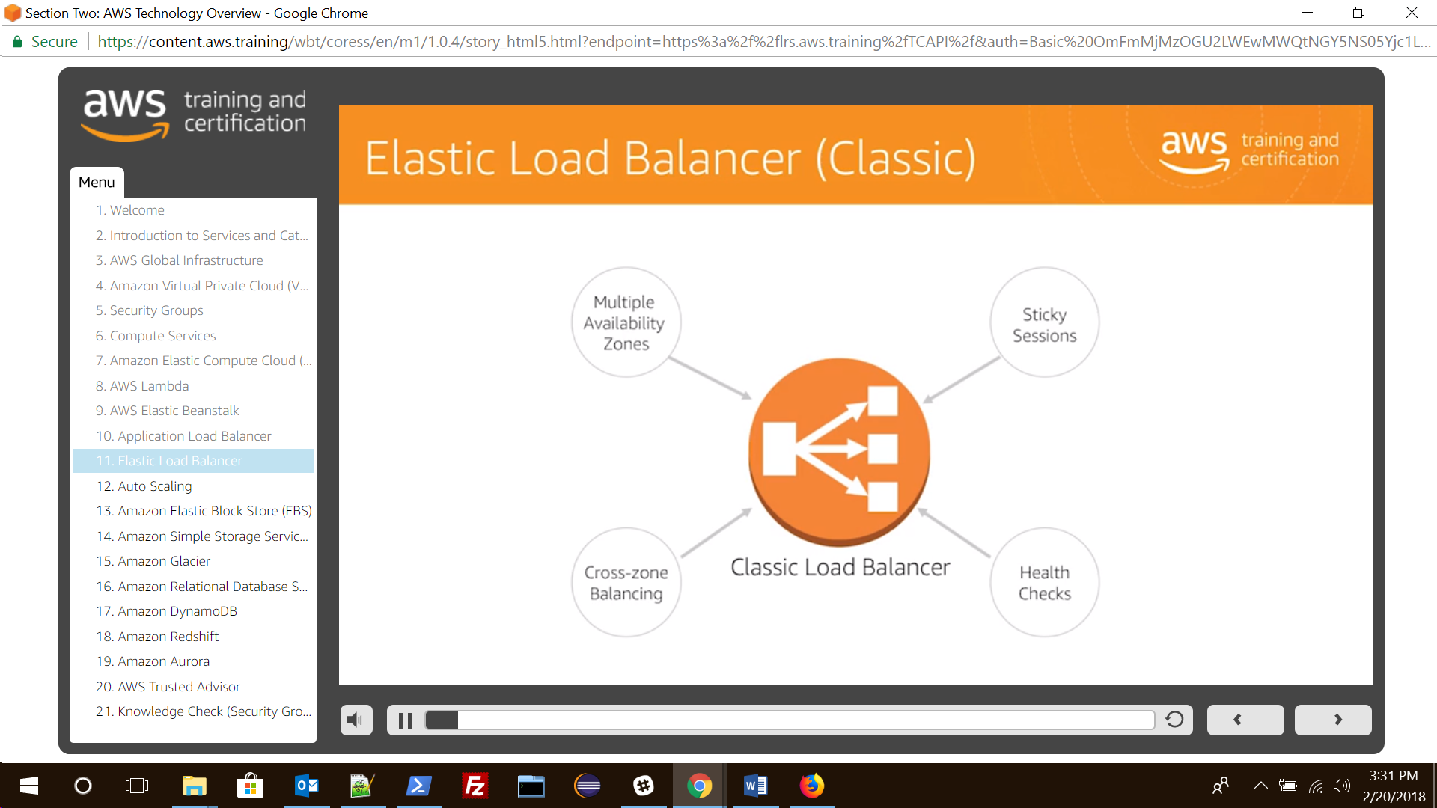

## 10. Auto Scaling

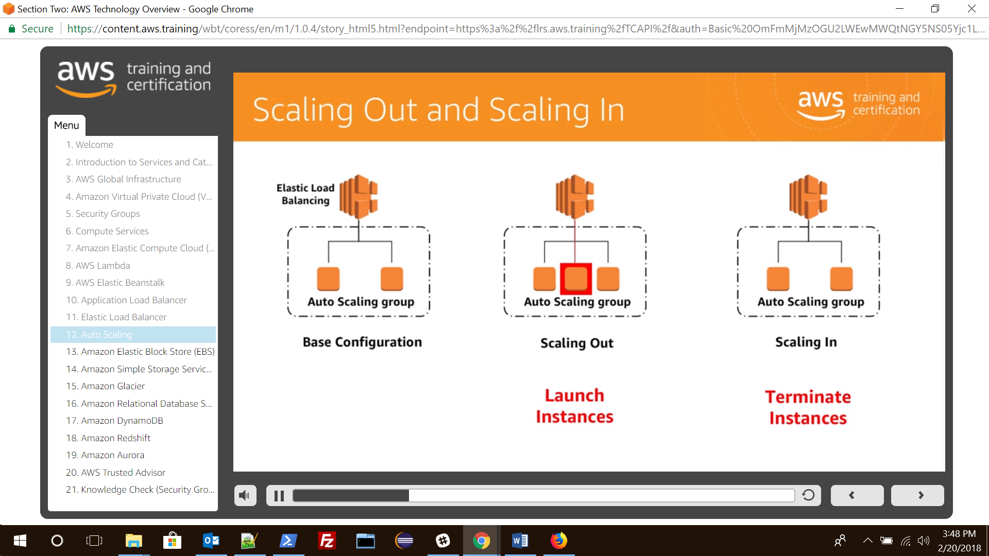

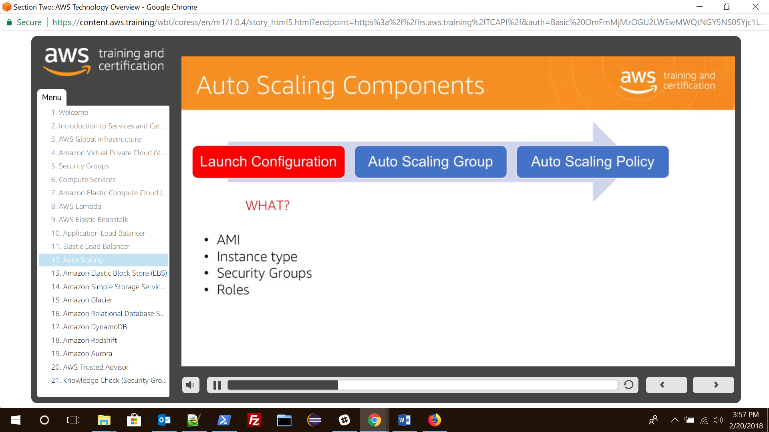

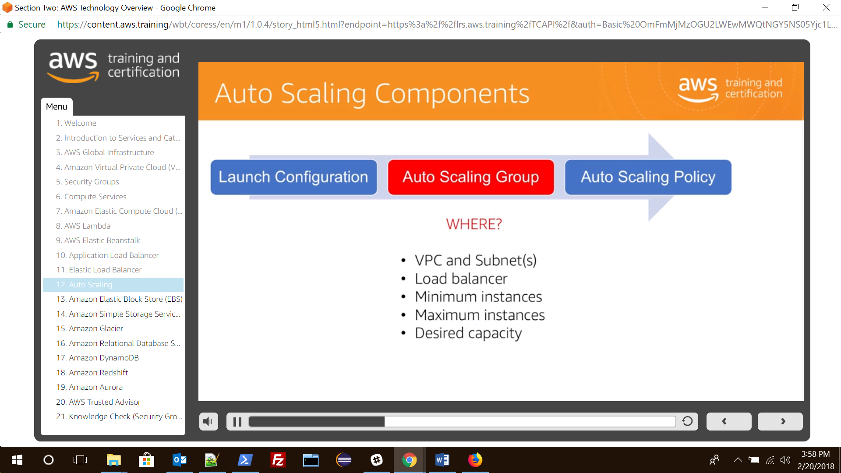

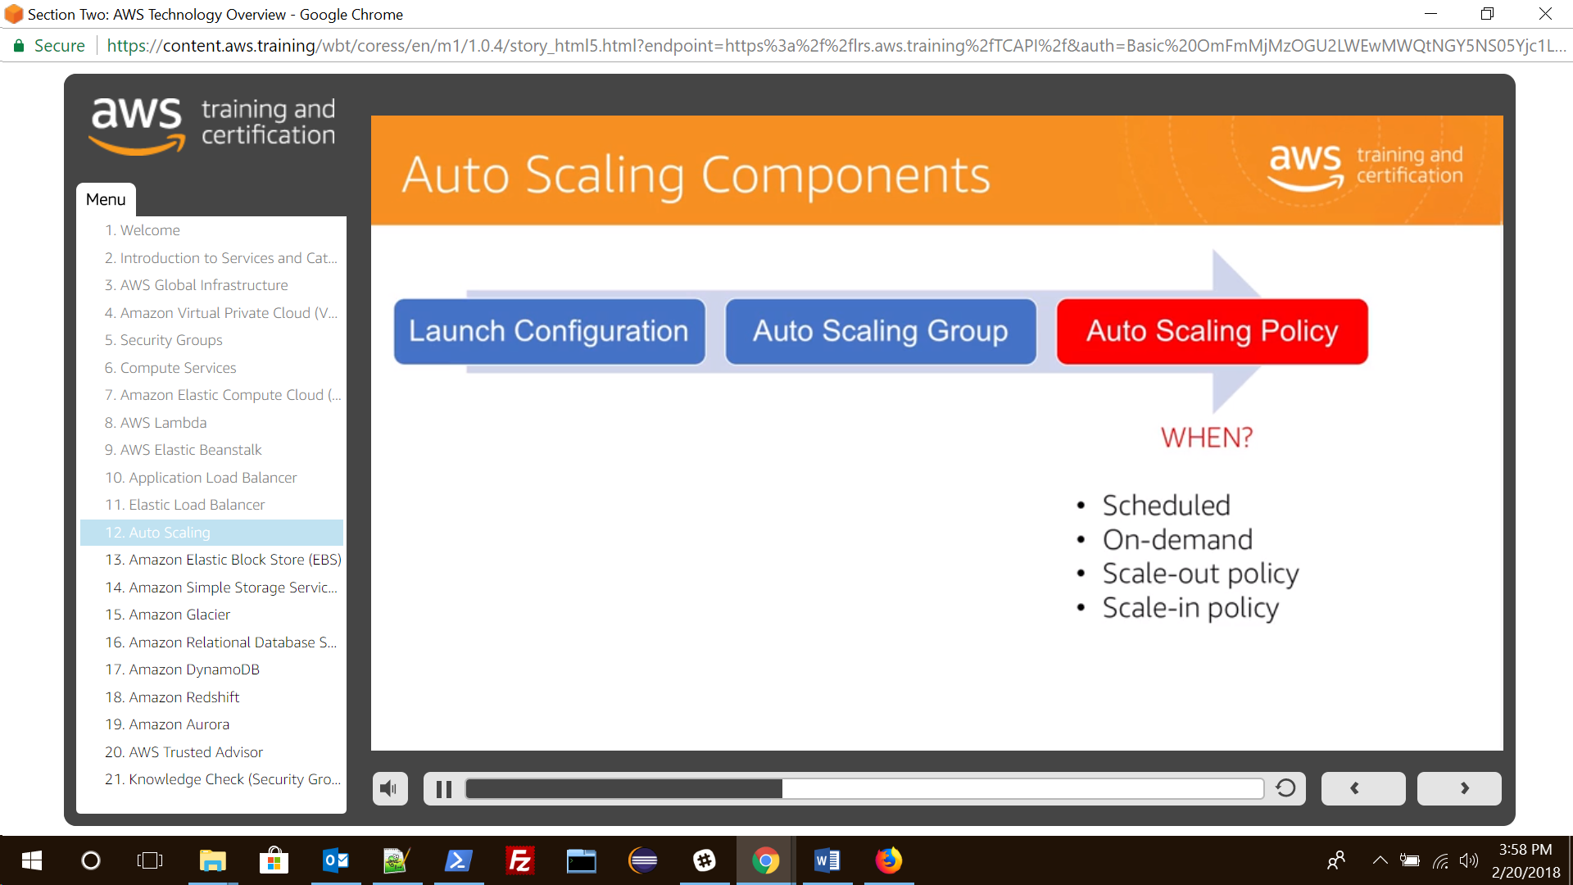

A sample scenario for Auto scaling

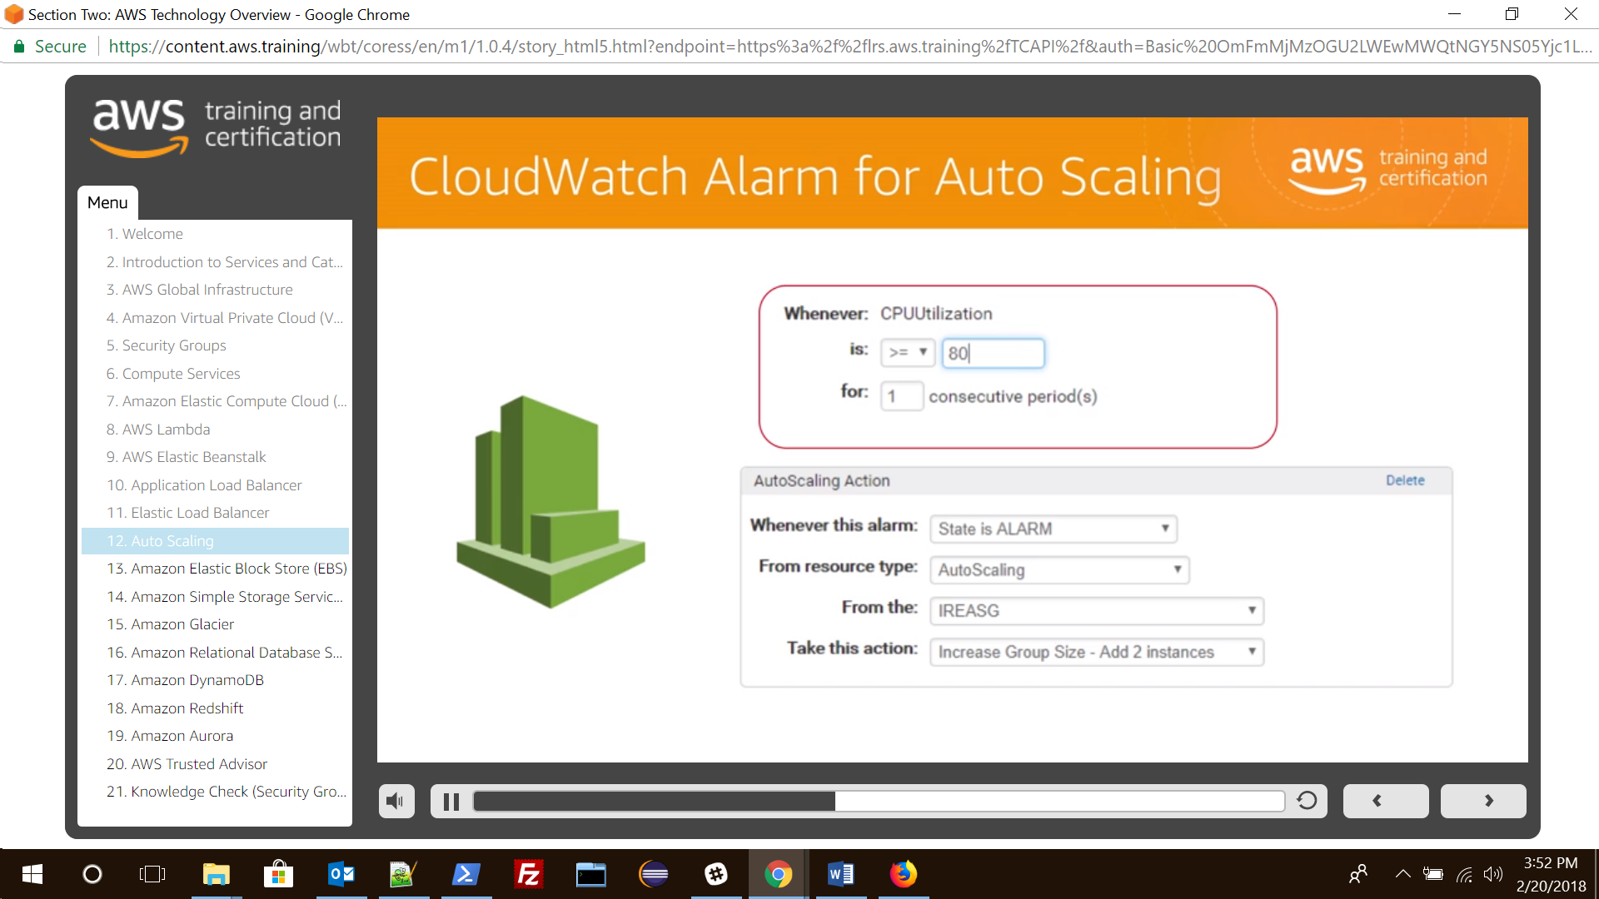

Create Auto scale group first.

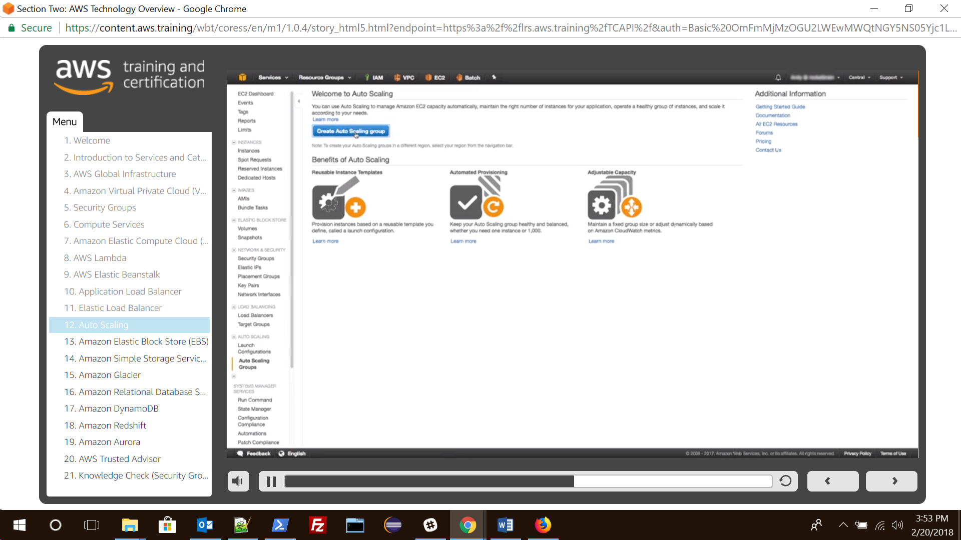

After this it will take to launch configuration which is similar to launching EC2 machines.

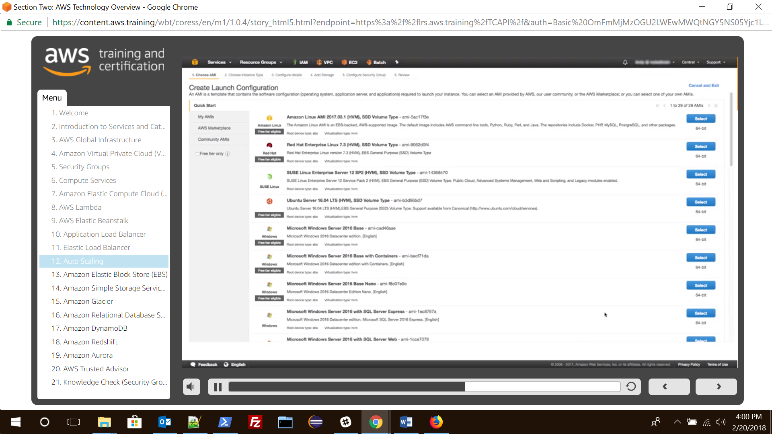

Once we have configured to launch configuration then it will take to Auto scaling Group , where basic information such as min instances and subnet etc are mentioned.

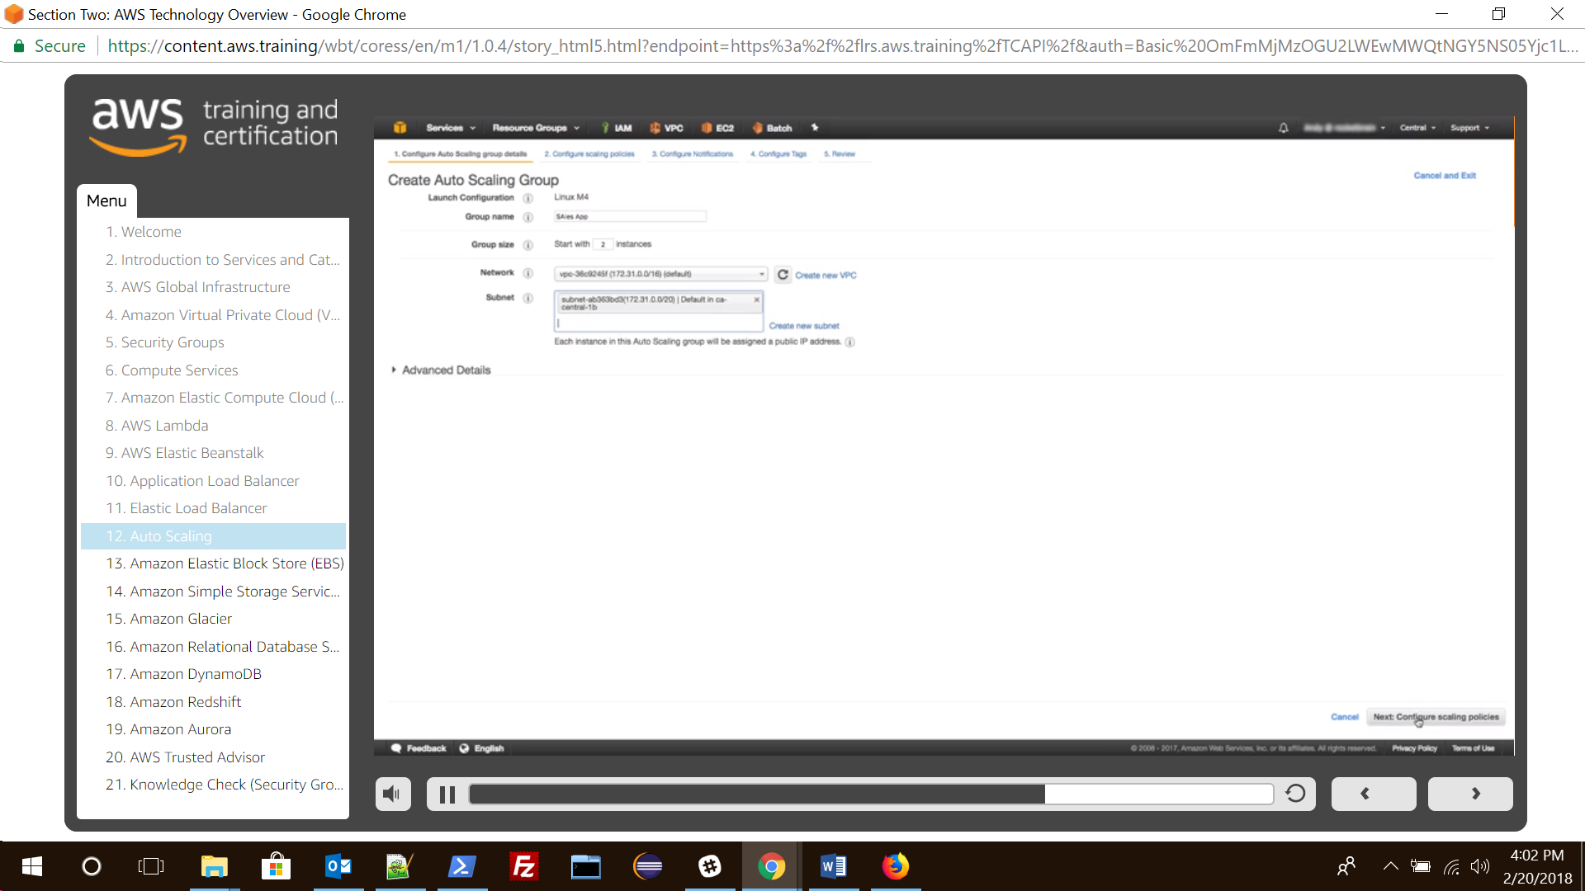

After creating scaling group it will take to scaling policy screen, where we will have to set up scaling policy.

